Eric Blasko

Dr. Tong Yu

CSE 461

March 2019

Lab 5 – Distributed Computing

**Note – This lab was completed independently. Also, as a reminder, for labs attendance, I am in the room across the hall as I am the TA for cse460. This was approved by Tong Yu. Each section has code or screenshots, followed by a discussion. Extra Credit in second part completed

**Part 1 Remote Procedure Call (random number – single host)**

$**rpcgen -C -a rand.x**

In this command, what are the purposes of the switches **-C** and **-a**?

Answer: -C generates code in ANSI C, this option also generates code that could be compiled with the c++ compiler. -a generates all the files including sample code for the client and server side.

**Rand.x**

program RAND_PROG {

version RAND_VERS {

void INITIALIZE_RANDOM (long) = 1;

double GET_NEXT_RANDOM (void) = 2;

} = 1;

} = 005670557;

**Rand_server.c**

#include "rand.h"

#include <time.h>

void *

initialize_random_1_svc(long *argp, struct svc_req *rqstp)

{

static char * result;

return (void *) &result;

}

double *

get_next_random_1_svc(void *argp, struct svc_req *rqstp)

{

static double result;

double range = (1000 - 0);

double div = RAND_MAX / range;

srand(time(NULL));

result += (rand() / div);

printf("%f \n",result);

return &result;

}

**Rand_client.c**

#include "rand.h"

double

rand_prog_1(char *host)

{

CLIENT *clnt;

void *result_1;

long initialize_random_1_arg;

double *result_2;

char *get_next_random_1_arg;

#ifndef DEBUG

clnt = clnt_create (host, RAND_PROG, RAND_VERS, "udp");

if (clnt == NULL) {

clnt_pcreateerror (host);

exit (1);

}

#endif /* DEBUG */

result_1 = initialize_random_1(&initialize_random_1_arg, clnt);

if (result_1 == (void *) NULL) {

clnt_perror (clnt, "call failed");

}

result_2 = get_next_random_1((void*)&get_next_random_1_arg, clnt);

if (result_2 == (double *) NULL) {

clnt_perror (clnt, "call failed");

}

#ifndef DEBUG

clnt_destroy (clnt);

#endif /* DEBUG */

return *result_2;

}

int

main (int argc, char *argv[])

{

char *host;

if (argc < 2) {

printf ("usage: %s server_host\n", argv[0]);

exit (1);

}

host = argv[1];

rand_prog_1 (host);

double x;

int i;

printf("\n 20 Random Numbers\n");

for(i=0; i <20; i++)

{

x = rand_prog_1(host);

printf(" %f, \n", x);

}

exit (0);

}

Client on jb358-1

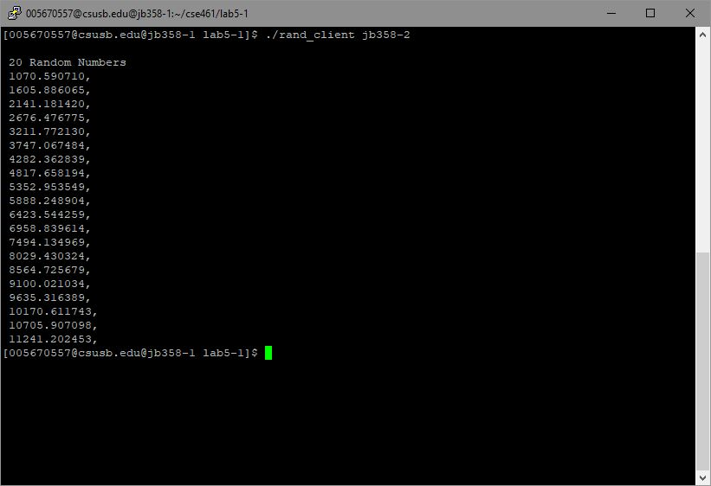

Server on jb358-2

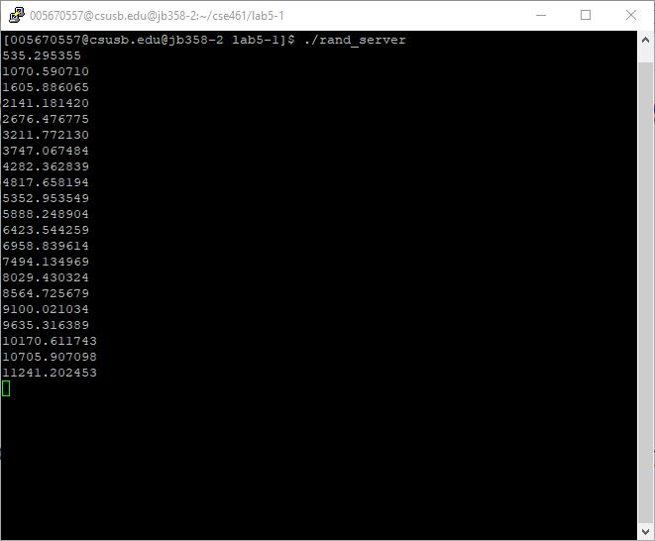

**Part 2 (Parallel Random Number Gen – with extra credit)**

**Rand.x**

struct params

{

int xleft;

int xright;

};

program RAND_PROG {

version RAND_VERS {

int GET_NEXT_RANDOM (params) = 1;

} = 1;

} = 005670557;

**Rand_server.c**

#include "rand.h"

int *

get_next_random_1_svc(params *argp, struct svc_req *rqstp)

{

static int result;

int xl, xr;

xl = argp->xleft;

xr = argp->xright;

result = (11*xl+13*result+4*xr) %31;

printf("%d\n",result);

return &result;

}

**Rand_client.c**

#include <SDL/SDL.h>

#include <SDL/SDL_thread.h>

#include "rand.h"

#define N 4

char *hosts[N];

SDL_mutex *mutex;

SDL_cond *barrierQueue;

int count = 0;

int era = 0;

int x[N];

int rns[N][10];

int

rand_prog_1(char *host, int xl, int xr)

{

CLIENT *clnt;

int *result_1;

params get_next_random_1_arg;

get_next_random_1_arg.xleft = xl;

get_next_random_1_arg.xright = xr;

clnt = clnt_create (host, RAND_PROG, RAND_VERS, "udp");

if (clnt == NULL) {

clnt_pcreateerror (host);

exit (1);

}

result_1 = get_next_random_1(&get_next_random_1_arg, clnt);

if (result_1 == (int *) NULL) {

clnt_perror (clnt, "call failed");

}

clnt_destroy (clnt);

return *result_1;

}

void barrier()

{

int myEra;

SDL_LockMutex(mutex);

count++;

if(count < N) {

myEra = era;

while(myEra == era)

SDL_CondWait(barrierQueue, mutex);

} else {

count = 0;

era++;

SDL_CondBroadcast(barrierQueue);

}

SDL_UnlockMutex(mutex);

}

int threads (void *data)

{

int i, i_minus_1, i_plus_1, id, xleft, xright;

id = *((int*) data);

printf("Thread %d",id);

for(i=0; i < 10; i++){

i_minus_1 = id -1;

if(i_minus_1 < 0)

i_minus_1 += N;

xleft = x[i_minus_1];

i_plus_1 = (id+1) % N;

xright = x[i_plus_1];

x[id] = rand_prog_1 (hosts[id], xleft, xright);

printf("(%d: %d)",id,x[id]);

rns[id][i] = x[id];

barrier();

}

return 0;

}

int

main (int argc, char *argv[])

{

int i, j;

SDL_Thread *ids[N];

if (argc < 5) {

printf ("usage: %s server_host1 host2 host3 host4..\n", argv[0]);

exit (1);

}

mutex = SDL_CreateMutex();

barrierQueue = SDL_CreateCond();

for(i = 0; i < N; i++)

x[i] = rand() % 31;

for(i = 0; i < N; i++){

hosts[i] = argv[i+1];

ids[i] = SDL_CreateThread (threads, &i);

}

for(i = 0; i < N; i++)

SDL_WaitThread (ids[i], NULL);

printf("\nRandom Numbers:");

for(i=0;i<N;i++)

{

printf("\nFrom Server %d:\n",i);

for(j=0;j <10;++j)

printf("%d, ", rns[i][j]);

}

printf("\n");

exit (0);

}

Client on jb358-1

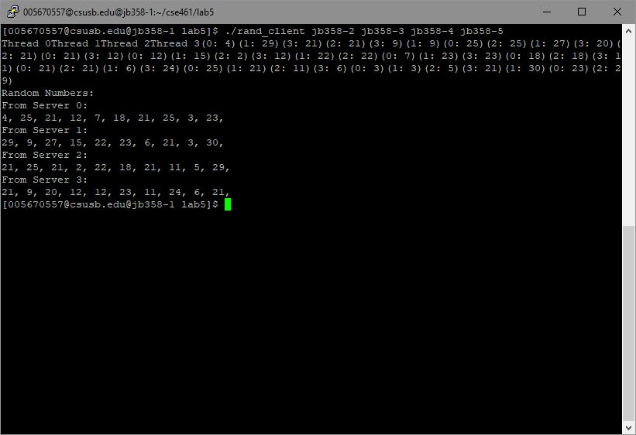

Server 1 on jb358-2

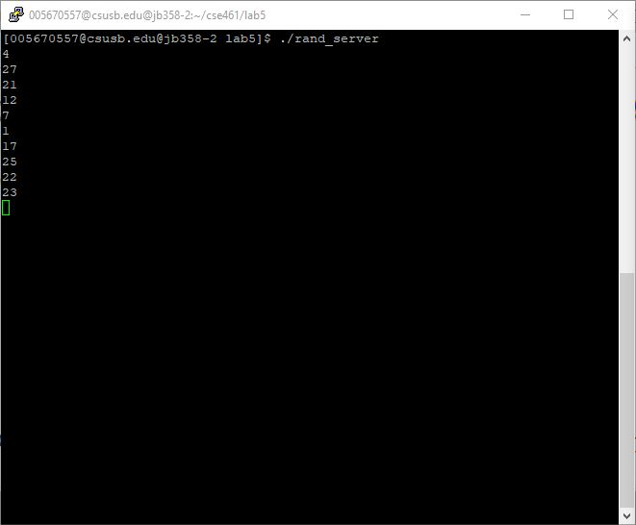

Server 2 on jb358-3

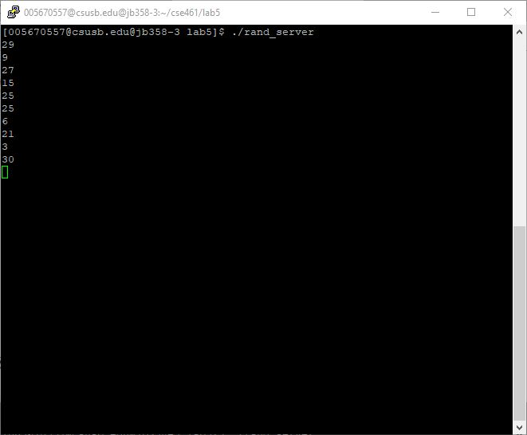

Server 3 on jb358-4

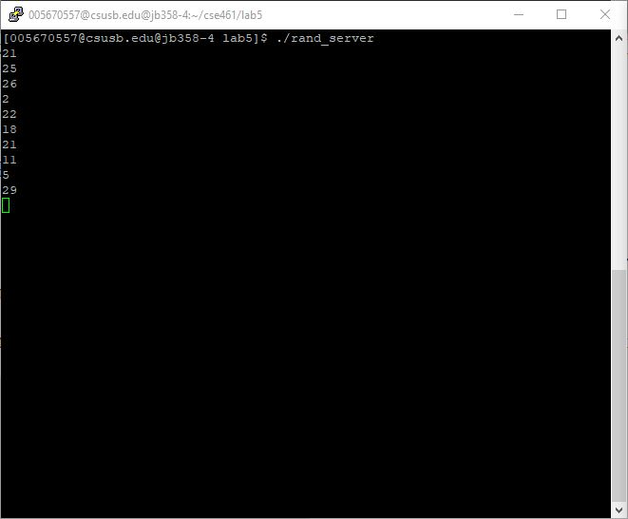

Server 4 on jb358-5

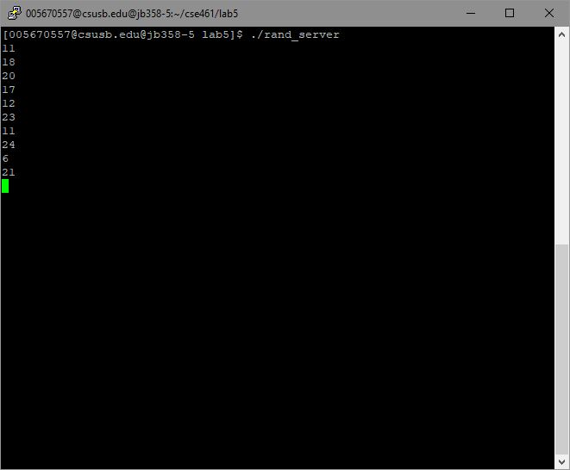

**Discussion/self-evaluation (30/20) extra credit completed**

I was able to complete all required sections of this lab. For the first part I was able to alter the client/server code so that the server generated random numbers every time. The range, however, was keeps intestinally between 0 and 1000. This can easily be altered to generate random numbers between any range. I also edited the server side to print out the results of each number that was generated.

For the second part, I was also able to complete successfully. It did take a while to get to work as I was using jb359 computers which would not let the RPC connect. Once I switched over to jb358 computers, it worked perfectly. As for the extra credit section of this lab, I was able to successfully alter the code so that there could be 4 servers who would return values to the client. Overall, this was a great lab for learning how to use RPC messaging and how it works between the client and server side.